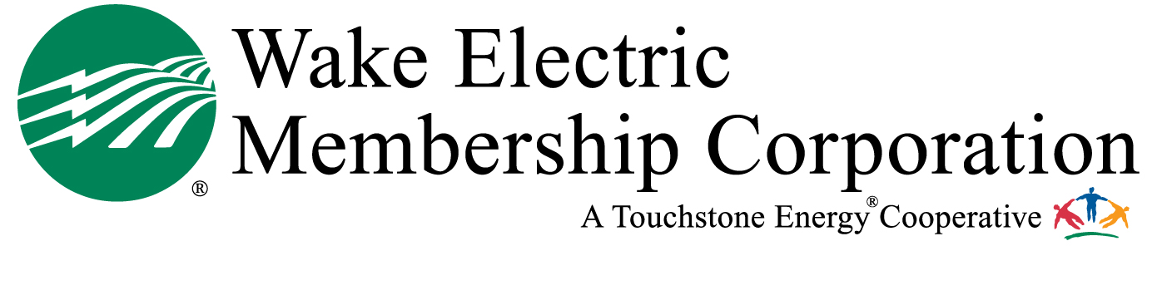

Post Office Box 1229
Wake Forest, North Carolina 27588-1229
Telephone: 919-863-6300 or 800-474-6300
Internet www.wemc.com

Memorandum
October 3, 2018

Wake Electric seeks applicants for a one-week, all expenses paid trip to Washington, D.C. for the 2019 Electric Youth Tour. Winners also receive a $1,000 scholarship. Winners must go on the Washington Trip to be eligible for the $1,000 scholarship. The trip will be from June 15 – 21, 2019. Students who attend the Youth Tour will join 1,500 high school students from across the U.S. to learn about electric cooperatives, American history and the U.S. government. Students will also visit the historic sites and federal facilities of the nation’s capital, as well as spend time with their congressional delegations. The $1,000 scholarship will be awarded the following year upon proof of enrollment in a North Carolina college or university.

The deadline to apply is December 12, 2018 by 5:00 p.m. Applications must be in our office by the deadline. Any applications received after that date will be disqualified. Applicants will be notified of their status in mid-January 2019.

Applicants must currently be high school juniors in Durham, Franklin, Granville, Johnston, Nash, Vance and Wake counties. Applicants DO NOT have to live in households served by Wake Electric in order to win.

For exciting details on the Youth Tour and what you can expect, visit www.youthtour.coop. To download an application, visit www.wemc.com/youth-tours/.

This opportunity is an excellent way for students to boost their college applications, as well as win a $1,000 scholarship from Wake Electric towards their college education. Youth Tourist winners from across North Carolina will also be eligible to apply for and win one of three annual scholarships: The Gwyn B. Prince Youth Scholarship ($2,500); The Katie Bunch Memorial Scholarship ($2,000) and the Youth Leadership Council Scholarship ($2,000).

If you have questions, please contact Wake Electric at communications@wemc.com or (919) 863-6312

.